Engineering Concepts

Compare and Contrast Careers in Engineering
Choose 2 of the following engineering disciplines that particularly interest you:
Mechanical | Chemical | Electrical | Civil | Geological
Aerospace | Biomolecular | Computer | Structural | Petroleum
Biomedical | Environmental | Electronics | Architectural | Nuclear
Biomechanical | Material | Robotics |  | Marine
Automotive | Agricultural | Microelectronic |  | Ceramics
Manufacturing | Textile | Mechatronics |  | Metallurgical
Systems | Nanotechnology | Industrial |  | Geomatics
You are to compare and contrast these 2 disciplines with a minimum of the following criteria:
- Educational and licensing requirements
- Top area colleges offering degrees in field
- Employment facts
- Job outlook
- Job description
- Earnings
You may choose one of the following types of organizers to display the information: a Venn Diagram, a Side-by-Side Diagram, Top Hat Organizer, or a Y Organizer.
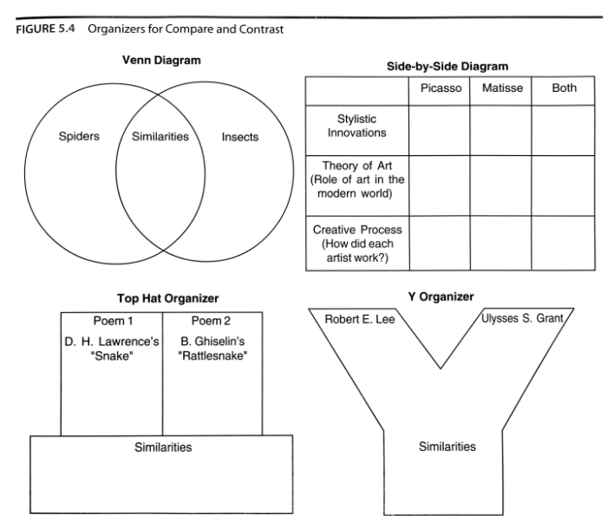
(The Strategic Teacher, by Silver H., Strong, R., and Perini, M., pg 77)
After examining the detailed content, write a one paragraph reflective essay on your personal thoughts concerning which discipline you would currently be more interested in pursuing.

